**Add stock/company or document related Image here,**

*Once you add image, click on it got to “Picture format” and than from “Arrange” tab go to the “sent to back” and click sent to back option. Also make sure the wrap the image “behind text” is also checked. And manually position image.*

Interview Question Bank &   
Candidate Evaluation Forms

**For Use in the Health Sector**

**Updated: April 5, 2025**

www.yourwebsite.com

**Add Your Company Logo/Name here**

**Table of Contents**

Disclaimer: 2

How to Use This Document 2

Introduction & Purpose 3

Key Objectives & Milestones 3

30-Day Plan: Orientation & Initial Training 3

Objective: Build a Strong Foundation 3

Check-in at the End of 30 Days: 4

60-Day Plan: Performance & Integration 4

Objective: Improve Efficiency & Build Confidence 4

90-Day Plan: Mastery & Long-Term Goals 5

Objective: Demonstrate Mastery & Plan Career Growth 5

Final Review at 90 Days: 5

Performance Review & Feedback Process 5

Support Resources & Ongoing Development 5

Acknowledgment & Agreement 6

Final Notes 6

# Disclaimer:

This **Interview Question Bank & Candidate Evaluation Forms** guide is designed to help employers **conduct structured, fair, and legally compliant interviews**. Employers must ensure compliance with **Ontario Employment Standards Act (ESA), Ontario Human Rights Code, and Accessibility for Ontarians with Disabilities Act (AODA)**. This document does **not** constitute legal advice and should be reviewed by HR professionals before implementation.

# How to Use This Document

This document serves as a **comprehensive resource for conducting structured, legally sound, and modern interviews**. Employers should:

* **Customize interview questions** based on the role, industry, and current job market trends.
* **Ensure compliance** with **ESA, OHSA, AODA, and human rights regulations**.
* **Use structured evaluation forms** to maintain consistency and fairness.
* **Incorporate modern best practices** including remote interviewing strategies.
* **Train interviewers** on unconscious bias awareness and inclusive hiring.
* **Document candidate responses and evaluations** for transparency and compliance.

# Introduction & Purpose

Effective hiring requires structured, fair, and legally compliant interviews that reflect modern workplace needs, digital transformations, and diversity considerations. This document provides:

* A structured, updated interview question bank aligned with today’s job market.
* Legally sound interview guidelines to prevent discrimination and bias.
* Candidate evaluation forms to ensure consistent assessment and scoring.
* A scoring system to support objective, data-driven hiring decisions.
* Inclusion of modern workplace trends, such as remote work and AI-driven roles.

# Legal Considerations & Compliance

Interviewers must comply with the following laws:

**Ontario Human Rights Code** – Ensures interviews are free from discrimination based on age, gender, race, disability, religion, or marital status.

**Accessibility for Ontarians with Disabilities Act (AODA)** – Ensures interviews accommodate candidates with disabilities, including for remote hiring.

**Employment Standards Act (ESA)** – Covers hiring standards for minimum wage, overtime, and employment contracts.

**Privacy & Data Protection Laws** – Candidate information must be stored securely and used only for hiring decisions.

**Prohibited Interview Topics:** Interviewers must NOT ask questions related to:

❌ Marital status, pregnancy, or family plans

❌ Age, nationality, or citizenship status

❌ Religious beliefs or affiliations

❌ Political opinions or union affiliations

❌ Medical conditions or disabilities (unless related to job requirements)

# Interview Best Practices

* **Competency-Based Interviews** – Focus on skills over academic credentials.
* **Blind Hiring Practices** – Reduce bias by anonymizing resumes during the initial screening.
* **Remote Interview Adaptation** – Ensure a smooth virtual hiring process for remote employees.
* **Inclusive Hiring** – Ensure interview questions support diversity, equity, and inclusion (DEI).
* **Structured Interviews with Scorecards** – Maintain fairness by scoring candidates on objective criteria.

# Structured Interview Question Bank

## A. General Behavioral Questions

* Tell me about yourself beyond your resume—what drives you?
* How do you prioritize tasks when everything seems urgent?
* What is a work accomplishment that you're most proud of?
* What’s a valuable lesson you've learned from a past mistake?

## B. Job-Specific & Technical Questions

* How do you stay current in your industry with emerging technologies?
* Walk me through a recent project where you used [specific skill].
* What’s your process for troubleshooting an unexpected issue in your field?
* How would you approach training a new hire in your area of expertise?

## C. Situational & Problem-Solving Questions

* If you had to complete an important task with limited resources, how would you proceed?
* Imagine a client/team member rejects your idea. How do you handle that?
* How would you react if you realized you made a critical error at work?

## D. Culture Fit & Diversity, Equity, and Inclusion (DEI) Questions

* How do you ensure an inclusive and respectful workplace?
* Share an experience where you collaborated with someone from a different background.
* How do you handle conflicts when working in a diverse team?

## E. Future-Proofing & Adaptability Questions

* What’s a new skill you've recently learned, and how did you apply it?
* Where do you see the biggest challenges in our industry in the next five years?
* How do you approach learning new tools or software quickly?

## F. Leadership & Strategic Thinking Questions

* How do you build trust with your team?
* What’s your decision-making process in high-pressure situations?
* Have you ever led an initiative that transformed a workplace process?

# Candidate Evaluation Forms

**Candidate Information:**

Candidate Name: _____________________________________________________________

Position Applied For: __________________________________________________________

Interviewer Name: _________________________________________ Date: ______________

**Evaluation Criteria & Scoring System (1-5 Scale)**

|  |  |  |
| --- | --- | --- |
| **Criteria** | **Score (1-5)** | **Comments** |
| Job Knowledge & Technical Skills |  |  |
| Communication & Interpersonal Skills |  |  |
| Problem-Solving & Adaptability |  |  |
| Cultural Fit & DEI Awareness |  |  |
| Leadership & Strategic Thinking |  |  |
| Overall Impression |  |  |

**Total Score:** ________/30

**Recommended for Next Stage?** (Yes/No): ______

**Additional Notes:** ___________________________________________________________

___________________________________________________________________________

___________________________________________________________________________

___________________________________________________________________________

___________________________________________________________________________

___________________________________________________________________________

___________________________________________________________________________

___________________________________________________________________________

___________________________________________________________________________

___________________________________________________________________________

___________________________________________________________________________

# Final Notes

This guide is designed to ensure compliance with Ontario labor laws while creating a structured onboarding experience. Employers should regularly update this document to reflect changes in workplace policies and legal requirements.

# Introduction & Purpose

The **30-60-90 Day Onboarding Plan** is designed to help new employees **transition smoothly into their roles**, ensuring they understand expectations, receive proper training, and contribute effectively. This plan:

* Helps employees develop job-specific skills and understand company culture.
* Provides clear performance expectations for each phase.
* Encourages open communication and feedback between employees and managers.
* Supports long-term employee retention and success.

# Key Objectives & Milestones

* 30 Days: Learn about company culture, complete training, and begin role-specific tasks.
* 60 Days: Apply skills independently, demonstrate efficiency, and integrate into the team.
* 90 Days: Achieve proficiency, contribute to business objectives, and set long-term goals.

# 30-Day Plan: Orientation & Initial Training

## Objective: Build a Strong Foundation

* + **Complete New Hire Orientation** – HR policies, company overview, and compliance training.
  + **Meet Team & Key Stakeholders** – Introduction to colleagues, leadership, and support networks.
  + **Understand Company Mission & Goals** – Learn about company values, services, and objectives.
  + **Complete Mandatory Training** – OHSA safety training, industry-specific requirements, data security, etc.
  + **Learn Role-Specific Responsibilities** – Review job description, key tasks, and expectations.
  + **Start Basic Work Tasks** – Shadow experienced team members, engage in hands-on practice.
  + **Review Workplace Tools & Systems** – Learn about software, reporting systems, and workflow tools.
  + **Schedule Bi-Weekly Check-ins** – Discuss progress, challenges, and additional support needs.

## Check-in at the End of 30 Days:

* Discuss first impressions, challenges, and support needed.
* Ensure training goals have been met.
* Identify any additional resources required.
* Provide initial performance feedback.

# 60-Day Plan: Performance & Integration

## Objective: Improve Efficiency & Build Confidence

**Demonstrate Understanding of Core Responsibilities** – Work independently on assigned tasks.

**Strengthen Collaboration & Communication** – Engage in team meetings, projects, and workplace interactions.

**Apply Feedback & Coaching** – Implement suggestions received from supervisors and peers.

**Enhance Productivity & Time Management** – Improve efficiency and workflow processes.

**Understand Performance Metrics** – Learn how performance is measured and assessed.

**Participate in Cross-Functional Training** – Gain insight into other departments’ functions.

**Develop Problem-Solving Skills** – Address minor challenges with minimal supervision.

**Check-in at the End of 60 Days:**

* Review progress on job duties and workplace adaptation.
* Identify gaps in skills or knowledge and plan additional training.
* Provide constructive feedback and recognize achievements.
* Adjust workload and responsibilities as necessary.

# 90-Day Plan: Mastery & Long-Term Goals

## Objective: Demonstrate Mastery & Plan Career Growth

**Fully Perform Job Duties** – Achieve confidence and consistency in all responsibilities.

**Enhance Problem-Solving & Decision-Making Skills** – Handle tasks with minimal supervision.

**Contribute to Team & Company Goals** – Participate in initiatives and take on new challenges.

**Develop Long-Term Growth Plan** – Identify career advancement opportunities and skill development goals.

**Prepare for Formal Performance Review** – Receive final feedback from the manager and discuss next steps.

**Seek Mentorship Opportunities** – Engage with senior team members for professional growth.

## Final Review at 90 Days:

* Confirm **role readiness and long-term fit** within the company.
* Identify **next steps for career progression**.
* Recognize **key achievements** and set **ongoing development goals**.
* Evaluate **employee satisfaction and engagement**.

# Performance Review & Feedback Process

Each milestone includes a **structured performance review and feedback session**:

* **30-Day Check-In:** Focus on orientation experience and early-stage learning progress.
* **60-Day Review:** Evaluate independent work ability, collaboration, and productivity.
* **90-Day Final Evaluation:** Determine overall success in onboarding and future growth plans.

# Support Resources & Ongoing Development

* **Access to Learning Management Systems (LMS)** – Employees can take online courses for continuous improvement.
* **Peer Mentorship Programs** – Encourage employees to connect with mentors for career guidance.
* **Regular One-on-One Meetings** – Scheduled coaching and professional development discussions.
* **Wellness & Employee Assistance Programs (EAPs)** – Support for mental health and work-life balance.
* **Annual Training Requirements** – Ongoing learning to maintain industry compliance and certifications.

# Acknowledgment & Agreement

I, **[Employee Name]**, acknowledge that I have received and reviewed the **30-60-90 Day Onboarding Plan** for [Company Name]. I understand my performance expectations and agree to follow the structured milestones outlined in this document.

**Employee Signature:** _________________________________________________________

**Date:** ______________________

**Manager/Supervisor Signature:** ________________________________________________

**Date:** _____________________

# Final Notes

This plan is designed to ensure compliance with Ontario labor laws while creating a structured onboarding experience. Employers should regularly update this document to reflect changes in workplace policies and legal requirements.

**Please delete the last page once you are done.**



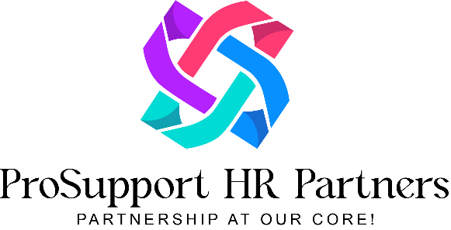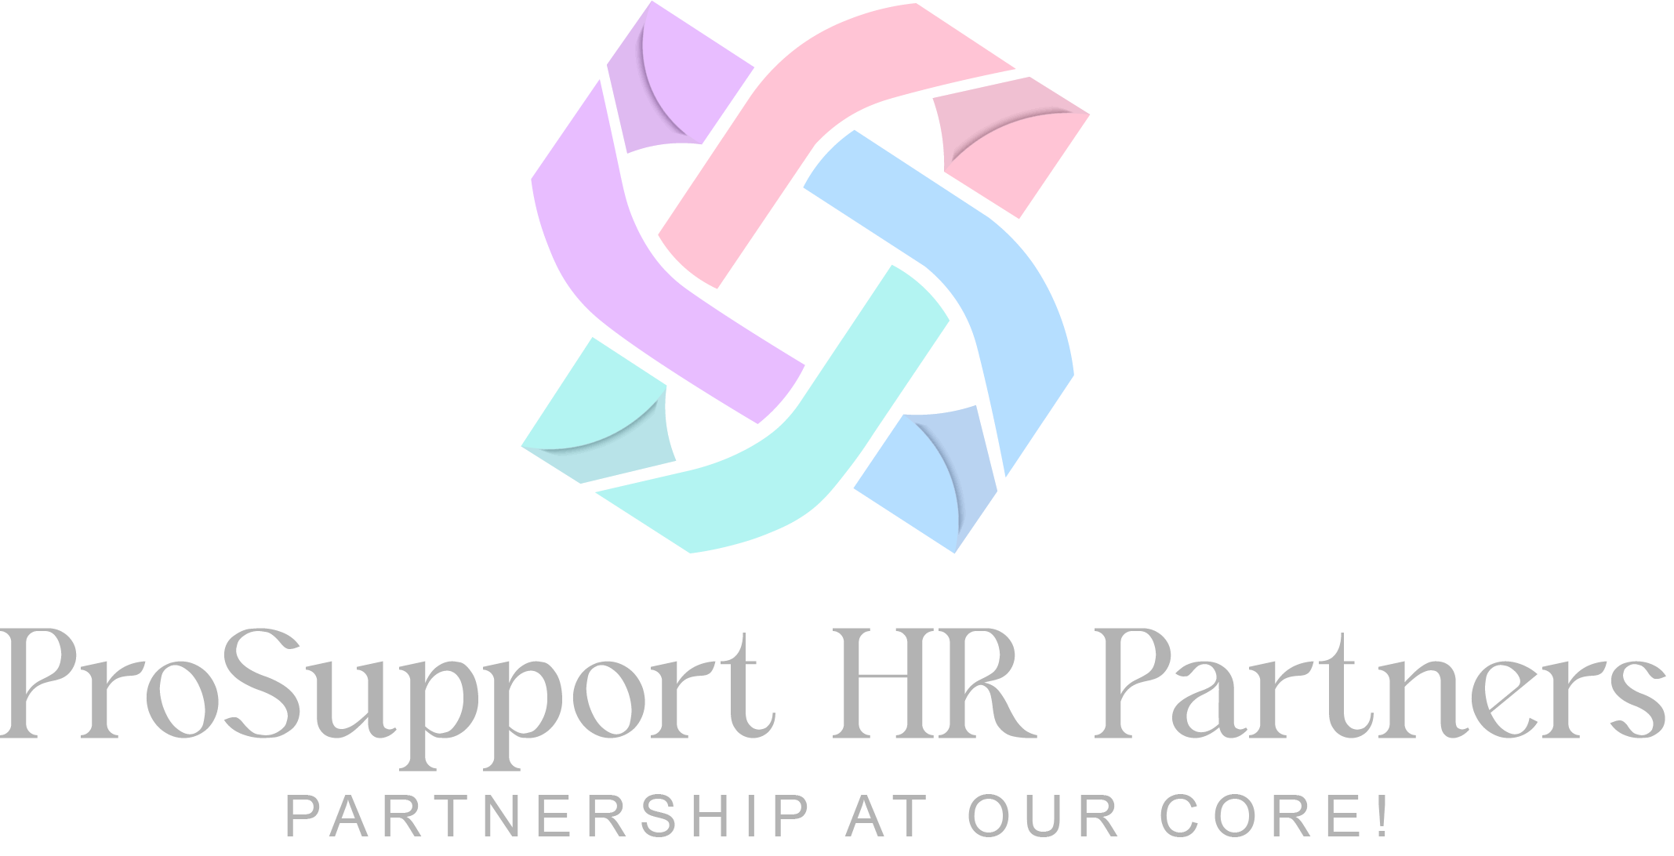

**Contact Us:**

**Email:** [contact@prosupporthr.ca](mailto:contact@prosupporthr.ca)

**Phone:** 289-628-1484

**Website:** <https://prosupporthr.ca>

**Copyright © 2025 Prosupport HR Partners**

All rights reserved. Unauthorized reproduction or distribution of this template is prohibited